Abstract: The total words in an abstract should not exceed 250 words. The abstract should brief the main principle of the paper and address the following areas without subsection titles. For instance, 1) the objective: it should shortly describe the problem statement of this paper, 2) the elements and the methods used in this paper: it should address the elements of the proposed idea in this paper as well as the new method applied to solve the problem, 3) the results: it should address the main results or the new findings as found in this paper, and 4) the conclusions: it should summarize the main points or impacts as addressed in this paper to draw much attentions to this paper.
Guideline of Paper Preparation for IAMBEST
Author Name¹, Author Name¹, Corresponding Author²*

¹ Affiliation of first author, organization, address, and Email
¹ Affiliation of second author, organization, address, and Email
^{2*} Affiliation of second author, organization, address, and Email

Index Terms—At least four keywords or phrases in alphabetical order, separated by commas.

INTRODUCTION
THIS document is mainly taken from IEET journal template in a format of Microsoft Word. This format is provided regarding to IEEE format as double-columned paper for IAMBEST conference that is held yearly by King Mongkut’s Institute of Technology Ladkrabang, Prince of Chumphon Campus, Chumphon, Thailand. The paper should be written with 4-6 pages, not larger than 6 pages. The structure of the paper includes many sections such as section I. Introduction, section II. Data Used and Methodology, sec

Data used
When you submit a manuscript, you must send your manuscript through a Web manuscript submission system.

Figures
Refer to the figures, before and after figures or figure captions, skip one line. If possible, figures should fit in one column, but if necessary, it will be permitted to have figures as wide as the full margin and centered. Maps should include a metric scale and north point. Photographs should be black and write, with good contrast. Any text in a figure or photograph should be large enough to be legible. Every figure title must have a number, which is an Arabic numeral without decimal notation. The description or explanation should not be more than two lines places under the center of the figure. Start the caption with “Fig. 1.” with font size #8 bold italic and the description should be font size #8 not bold, with first letter of each word capitalized. For example: Fig. 1. Three selected Global Positioning System (GPS) stations from the equator to the far low-latitude locations. As for the tables, they are like the figures, but all letters of the captions must be shown as capital letters and are placed above the center of the table without space

between the table caption and the table. For instance, Table I GEOGRAPHICAL LOCATIONS OF SELECTED GPS STATIONS

Electronic Image Files
Format and save your images using a suitable graphics processing program such as PostScript (PS) or Tagged Image File Format (TIFF) etc. If you build your source files in one of the following programs such as Microsoft Word, Microsoft PowerPoint, Microsoft Excel, or Portable Document Format (PDF), you can submit the images without converting to a PS file or a TIFF file.

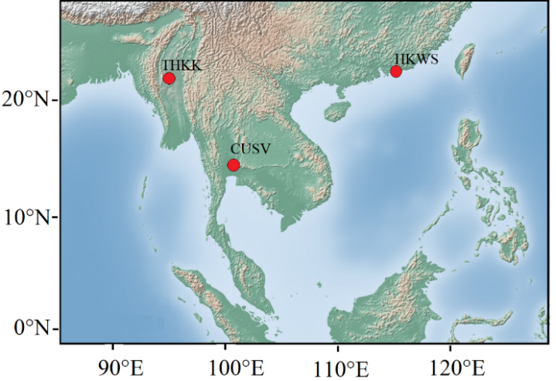

Fig. 1. Three selected Global Positioning System (GPS) stations from the equator to the far low-latitude locations.

TABLE I
geographical locations of Selected GPS stations

Station Code/ Country | Geog.  Latitude | Geog.  Longitude | Magnetic Dip
CUSV, Thailand | 13.73°N | 100.53°E | 15.83°
HKWS, China | 22.43°N | 114.33°E | 33.75°
THKK, Myanmar | 22.99°N | 95.15°E | 35.37°

Methodology
Please kindly number equations sequentially with equation numbers in parentheses flush with the right margin, as shown below in (1). For instance, the effect in a form of a linear fitting equation can be written as follows:

(1)

Here, a and b were constants, SNR is the signal to noise ratio, and ROTI is the rate of TEC change index. Describe each variable in each equation completely. Refer to “(1),” not “Eq. (1)” or “equation (1),” except at the beginning of a sentence: “Equation (1) is used to …..... .”

Results and discussion
In this section, the detailed variation of anomalous LST values for only three EQs are chosen to explain such as the EQs on March 13, 2005 (Iran) – case 4, May 20, 2012 (Italy) – case 10, and April 03, 2017 (Botswana) – case 13. Firstly, the EQ of M_{w} 6.0 hit the south-eastern part of Iran on March 13, 2005 as depicted in Fig. 2.

Fig. 2. Temporal daily LST values and the deviations (%Dev) for Mw 6.0 Iran EQ (case 4 in Table 1). The EQ day is showed by a black dashed line.

Conclusion
Please provide a summary with the main clear and outstanding description of your work in the conclusion section. Although a conclusion may review the main points of the paper, do not copy the abstract to be the conclusion. Acknowledgement is also expressed if the authors employ the data taken from any web portal. Particularly, the references must be written as an IEEE standard as shown below.
Acknowledgment
The authors would like to acknowledge the NASA and NOAA online data centers for the provision of MODIS-LST images and thank to USGS for making available EQs information. Moreover, this research is financially supported by Broadcasting Fund (grant number: B005/6-1-60).
References
[1] L. Cheng, K. Wang, M.F. Ren, X.Y. Xu, “Comprehensive analysis of multipath estimation algorithms in the framework of information theoretic learning”. IEEE Access. 6:5521-5530, 2018.
[2] L. Cheng, K. Wang, M.F. Ren, G. Yan, “Adaptive filter approach for GPS multipath estimation under correntropy criterion in dynamic multipath environment”, IEEE Trans Signal Process. 67(22):5798-5810, 2019
[3] M. R. Azarbad and M. R. Mosavi, A new method to mitigate multipath error in single-frequency GPS receiver with wavelet transform. GPS Solutions. 18(2):189-198, 2014
[4] K. Ansari and K. D. Park, “Multi constellation GNSS precise point positioning and prediction of propagation errors using singular spectrum analysis”. Astrophys Space Sci. 363(12):1-7, 258, 2018.
[5] Y. Gao, Z. Yao, X. Cui, M. Lu, “Analysing the orbit influence on multipath fading in global navigation satellite systems”. IET Radar, Sonar Navig. 8(1):65-70, 2014
[6] E. Amani , K. Djouani, J.R. De Boer, A. Kurien, W. Vigneau, “Correlator-based multipath detection technique for a global positioning system/GNSS receiver”. IET Radar, Sonar Navig, 12(7):783-793, 2018
[7] H.W. Seok, K. Ansari, C. Panachai, P. Jamjareegulgarn, “Individual performance of multi-GNSS signals in the determination of STEC over Thailand with the applicability of Klobuchar model”, Advances in Space Research, 69(3), 1301–1318, 2022
[8] C. Zhao, J. Ou, and Y. Yuan, “Positioning accuracy and reliability of GALILEO, integrated GPS-GALILEO system based on single positioning model,” Chinese Science Bulletin, vol. 50, no. 12, pp. 1252-1260, 2005.
[9] Y. Yang, B. Peng, X. Dong, L. Fan, L. Liu, and W. Wang, “Performance evaluation method of hybrid navigation constellations with invalid satellites. Science China Physics,” Mechanics and Astronomy, vol. 54, no. 6, pp.1046-1050, 2011.
[10] S. Tafazoli, M. R. Mosavi, and N. Rahemi, “Comparing GPS GDOP Approximation Accuracy using Recurrent Wavelet Neural Network and ARMA Modeling,” Journal of Information and Communication Technologies, vol. 1, no. 5, pp. 1-6, 2011.
[11] D. H. Won, J. Ahn, S. W. Lee, J. Lee, S. Sung, H. W. Park, J. P. Park, and Y. J. Lee, “Weighted DOP with consideration on elevation-dependent range errors of GNSS satellites,” IEEE Transactions on Instrumentation and Measurement, vol. 61, no. 12, pp. 3241-3250, 2012.
[12] F. Meng, S. Wang, and B. Zhu, “GNSS reliability and positioning accuracy enhancement based on fast satellite selection algorithm and RAIM in Multiconstellation,” IEEE Aerospace and Electronic Systems Magazine, vol. 30, no. 10, pp. 14-27, 2015.
[13] Y. Teng, J. Wang, Q. Huang, and B. Liu, “New characteristics of weighted GDOP in multi-constellation GNSS positioning,” GPS Solutions, vol. 22, no. 3, pp.1-9, 2018.
[14] Y. Teng and J. Wang, “New characteristics of geometric dilution of precision (GDOP) for multi-constellation GNSS constellations,” The Journal of Navigation, vol. 67, no. 6, pp. 1018-10,28, 2014.
[15] S. K. Biswas, L. Qiao, and A. G. Dempster, “Effect of PDOP on performance of Kalman Filters for GNSS-based space vehicle position estimation,” GPS Solutions, vol. 21, no. 3, pp.1379-1387, 2017.

